**Assignment -1 AWS -Creating and Managing a Windows Virtual Machine**

**Step1: EC2 Dashboard with Instance List with tag Name (Screenshot Given Below)**



**Step2: EC2 Running Instance Details Dashboard (Screenshot Given Below)**

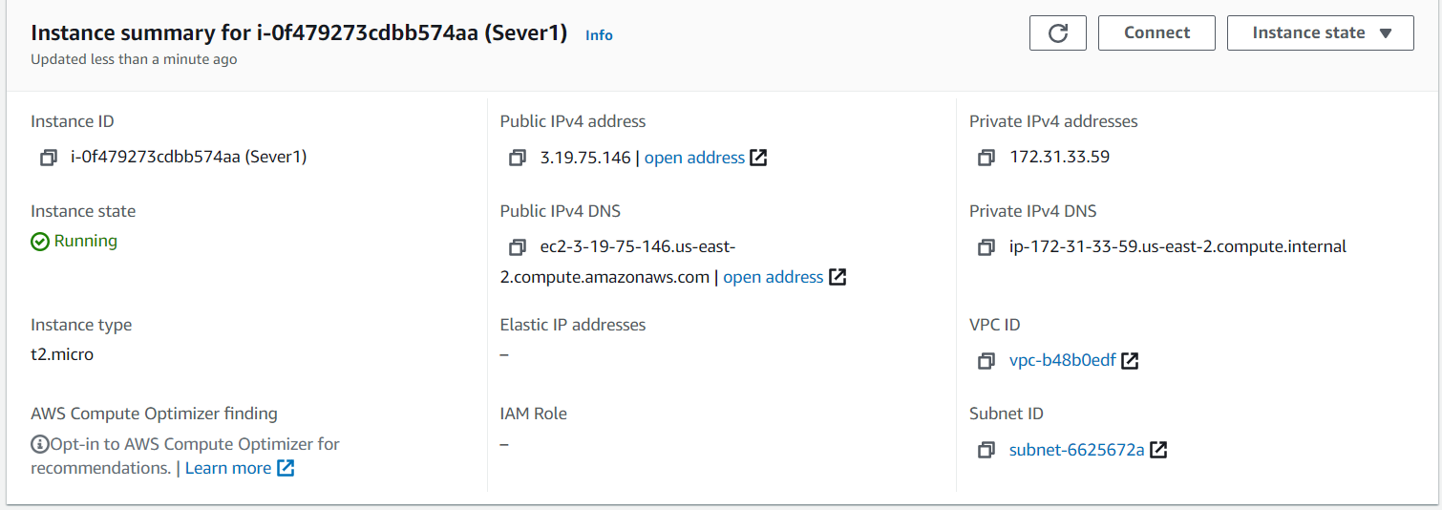

**Step3: Windows Screen After Lunch or Create RDP (Screenshot Given Below)**

